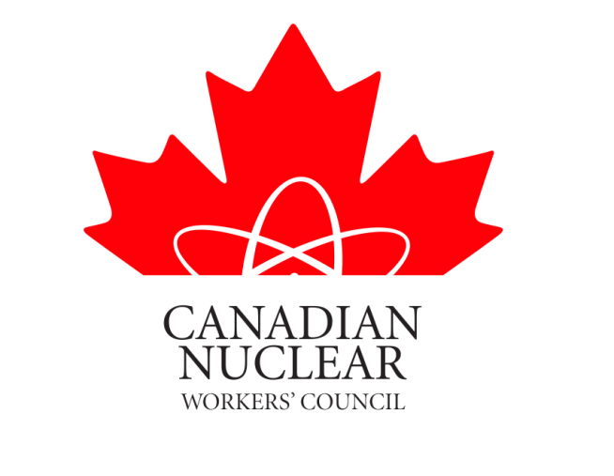

June 2021

CNWC Report on SMR Development/Deployment in Canada
The Canadian Nuclear Workers’ Council (CNWC)
The CNWC was formed in 1993 as an association of Unions representing Workers in all aspects of the Canadian nuclear industry (uranium mines and mills, nuclear fuel production, nuclear power plant (NPP) operation and maintenance, engineering, NPP construction and refurbishment, medical isotope production, nuclear research and development, nuclear waste handling and decommissioning). Our Membership also includes District Labour Councils in a number of host communities. http://cnwc-cctn.ca/
The goals of the CNWC are to:
- ensure the perspectives of Canada’s Nuclear Workers are heard by decision makers,
- strengthen the collective role of Nuclear Workers via their Unions as partners in Canada’s Nuclear Industry, and
- enhance public knowledge about the many benefits of Canada’s Nuclear Industry.
Potential for new nuclear power plant development
The development of small modular reactors (SMRs) has attracted a lot of interest in Canada and around the world. Canada has a rich nuclear heritage and we have used our strong experience with nuclear technology to take a lead in the development of SMRs. The strategic importance of nuclear power has reemerged because of growing concerns about climate change. The global race is now on but Canada is in a good position and can continue to lead. The federal government developed an SMR Roadmap followed by the SMR Action Plan. Our regulator, the Canadian Nuclear Safety Commission (CNSC), has been updating their regulations in anticipation of receiving applications from prospective licensees to construct and operate SMRs. The Premiers of Saskatchewan, Ontario, New Brunswick and Alberta have all agreed to collaborate on the development of SMRs.
Reference: Feasibility Report showing the economic and jobs benefits of SMR development https://www.ontario.ca/page/small-modular-reactor-feasibility-report
Ontario Power Generation (OPG) currently has a site with a valid environmental assessment and site preparation licence for a new nuclear generating station and has announced their interest in using this site for the deployment of an SMR. The expectation is that a “First-Of-A-Kind” SMR will be constructed by OPG and once it is successfully completed a “Next-Of-A-Kind” will potentially be built in Saskatchewan. This is starting to progress fairly quickly.
NB Power has selected two SMR technology developers with the expectation that both of their SMR designs could be deployed at site of the Point Lepreau Nuclear Generating Station as “First-Of-A-Kind” SMRs.
One of the key objectives of the CNWC is to share our experiences. Unions in the nuclear industry have firsthand knowledge of the benefits of nuclear power, including the many opportunities for high quality employment. In our experience collaboration between Unions and employers in the industry has led to the highest standards of workplace health and safety and a strong commitment to the protection of People and the Environment. Now is the right time to expand our lines of communication to include Unions at locations that may be the potential host of future nuclear projects. The CNWC and our Member Unions will help get answers to any related questions and consider setting up working groups as this evolves.
Small Modular Reactors (SMRs)
Reactors all use a nuclear fission reaction to create heat which can be used to generate electricity. Canadian power reactors are currently all Canadian designed CANDU Reactors (CANadian Deuterium Uranium). They use Heavy Water for their moderator and primary heat transport systems and use natural uranium fuel. They range in size from ~500 MWe to ~900 MWe.
SMRs will be smaller. They can range in size from <1 MWe to ~300 MWe. The larger SMRs will be built to supply our electricity grids. SMRs will be modular and incremental units can be added as required. The modules can be built in factories and assembled at site. Many SMRs will be modern designs but using technology that has been in use for many years with advanced safety features. Other SMRs will use advanced generation 4 technology. SMRs will likely require enriched uranium fuel which is currently not produced in Canada.
Nuclear power can provide a reliable supply of electricity without greenhouse gas emissions. SMRs can be used as baseload electricity or load-follow to support renewables. They can also be used for the production of hydrogen or process heat. This will help us achieve our carbon reduction goals.
There are a number of potential SMR vendors/designs in various stages of research/development and relationships continue to evolve with potential utilities/operators.
Canadian Small Modular Reactor (SMR) Leadership/Collaboration:
Natural Resources Canada (NRCan) established an SMR Roadmap Steering Committee comprised of representatives from various government and private entities (including Bruce Power, OPG, NB Power, and CNL) https://www.smrroadmap.ca then published an SMR Action Plan in December 2020 https://smractionplan.ca/.
Memorandum of Understanding on SMR development between Provinces. The Premiers of New Brunswick, Ontario and Saskatchewan signed an MOU in December 2019 committing to collaborate on the development and deployment of SMR Technology. The Government of Alberta signed the MOU in April 2021. https://news.ontario.ca/en/statement/61131/small-nuclear-reactor-study-released-alberta-signs-smr-mou
SMR Utility Working Group; OPG, NB Power, Bruce Power, Sask. Power, CNL, Candu Owners Group and the Canadian Nuclear Association.
Canada’s Nuclear Regulator, the Canadian Nuclear Safety Commission (CNSC), has done a lot of work to ensure they are prepared to respond to license applications for SMRs. The CNSC and the US Nuclear Regulatory Commission (US-NRC) signed a Memorandum of Cooperation to enhance technical reviews of SMRs. https://nuclearsafety.gc.ca/eng/reactors/research-reactors/other-reactor-facilities/small-modular-reactors.cfm
Canadian Nuclear Laboratories (CNL) is working with a number of project proponents. Details on SMRs and these projects can be found at https://www.cnl.ca/SMR.
The Canadian Nuclear Industry has categorized the development/deployment of SMRs into 3 streams.
Stream One
These are grid scale SMRs that are expected to be available for early deployment. OPG currently has a valid Environmental Assessment and a CNSC Power Reactor Site Preparation Licence for a new nuclear project at the site of their Darlington Nuclear Power Plant. OPG has stated their intention to use this site for the deployment of an SMR. OPG plans to have an SMR in-service at Darlington around 2028. This will be a “First-Of-A-Kind” project with the anticipation of a subsequent “Next-Of-A-Kind” project in Saskatchewan.
OPG has narrowed this down to 3 potential technology developers and expects to make a technology decision later in 2021 followed by an application to the CNSC in 2022 for a Licence to Construct. Note: All use enriched uranium.
- Terrestrial Energy, IMSR 400 Integrated Molten Salt Reactor. 195 MWe reactor that can be scaled into a 2-unit plant = 390MWe. https://www.terrestrialenergy.com/media/terrestrial-energy-leading-the-way-to-a-bright-energy-future/ . Canadian Company. They have received some funding from the federal government through the Strategic Innovation Fund.
- GE Hitachi, BWRX-300, 300 MWe Boiling Water Reactor. https://www.ge.com/news/press-releases/ge-hitachi-nuclear-energy-advances-efforts-to-license-bwrx-300-small-modular-reactor
- X-Energy, Xe-100, 80 MWe reactor that can be scaled into a ‘four-pack’ = 320 MWe power plant. https://x-energy.com/media/news-releases/x-energy-delivers-second-information-package-for-cnsc-pre-licensing-canadian-vendor-design-review
Stream Two
These are advanced grid-scale reactors that claim some sustainability advantages (e.g. use recycled CANDU fuel or extract more energy out of the uranium fuel cycle). They are currently in development with potential deployment in the mid-2030s. NB Power is leading this work with two developers, ARC and Moltex. Both have completed phase one of the CNSC vendor design review.
- Advanced Reactor Concepts (ARC). ARC Clean Energy Canada Inc. (ARC Canada) is developing the ARC-100. US/Canada Company. https://www.arcenergy.co/
- MOLTEX, Moltex Energy, 300-1,000MWe. UK/Canada Company. https://www.moltexenergy.com/
Stream Three
These are the very small modular reactors (vSMRs) for off-grid uses such as remote mines or communities currently using diesel to generate electricity.
- Global First Power, Ultra Safe Nuclear Corporation™ and OPG formed a joint venture to build, own, and operate a Micro Modular Reactor (MMR) at Canadian Nuclear Laboratories’ Chalk River site. The environmental assessment is in progress and GFP is in preparing an environmental impact statement with a target date of 2026. http://www.gfpcleanenergy.com/Home/VOH https://www.globalfirstpower.com/
- Westinghouse eVinci. Bruce Power is working with Westinghouse on the eVinci “battery” style reactor. https://info.westinghousenuclear.com/news/bruce-power-and-westinghouse-collaborate-to-advance-application-of-evinci
SMRs Miscellaneous
- CANDU C-SMR based on the CANDU 3. I have included this because it is 100% Canadian technology and does not require enriched uranium fuel. https://www.snclavalin.com/~/media/Files/S/SNC-Lavalin/download-centre/en/brochure/our-candu-smr_en.pdf
- NuScale is developing a demonstration reactor at Idaho National Laboratory. A plant can have as many as 12 modules with each module producing 77 MWe. NuScale says they can have modules ready by 2027. I have included this because NuScale has received final design approval from the US Regulator, the NRC. https://www.nuscalepower.com/projects/current-projects/canada

Bob Walker
National Director
Canadian Nuclear Workers’ Council
bwalker@cnwc-cctn.ca

